Connecting to the GoeMobile Wi-Fi network

Requirements
1.) student account: You'll need a studIT account or a GWDG account (an account for employees of Göttingen University) to access the internet via GoeMobile. It is not necessary to register separately.
2.) hardware: For using wireless LAN you'll need a computer with a Wi-Fi card (802.11b/g). Today's laptops do have an integrated Wi-Fi card. If this card is not available, you'll need an external USB-device or a PCMCIA plug-in card for your laptop, which can be bought for around 30 Euros each. You can use every network adapter which supports standard IEEE 802.11b/g.
Attention: At the University Hospital the wireless network GoeMobile is not available. Please use eduroam there!

How to use GoeMobile

Connecting to GoeMobile with Windows XP / Vista
In order to connect make sure that the network adapter is activated or switched on (for notebooks: often via switch/button!). Connect to the wireless network „GoeMobile“.
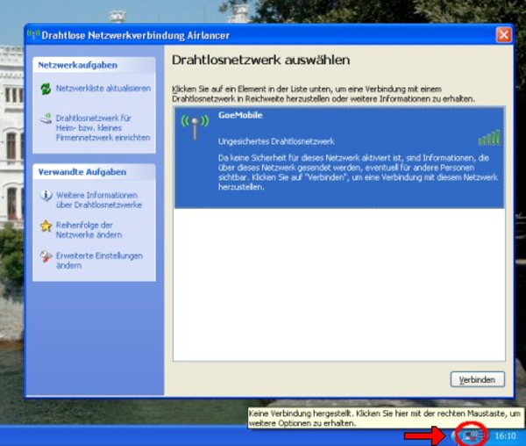
In Windows XP / Vista the wireless adapter icon can be found in the lower right corner of the task bar next to the clock (Windows Vista: double click → „connection to a network“; Windows XP → „show available connections“). The network itself is unencrypted (a secure connection can be established later via VPN).

Using the portal page
After connecting to the network you will be lead directly to the portal page of GoeMobile for authentication.
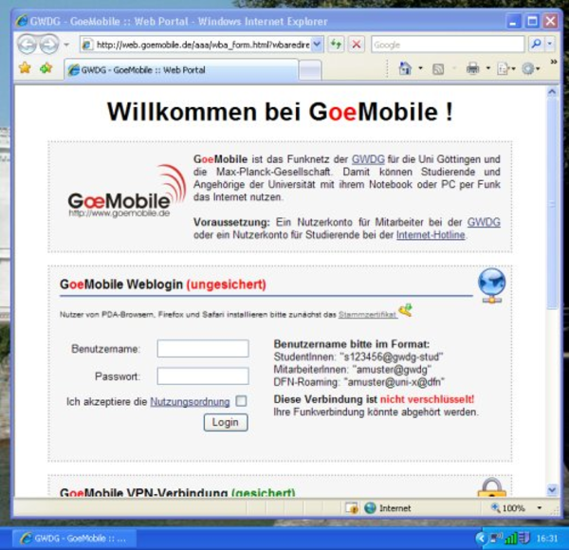
For students: Please type your username with the ending @gwdg-stud in the box.
example: Maxi.Musterfrau@gwdg-stud
You also can use your student e-mail address as username:
example: Maxi.Musterfrau@stud.uni-goettingen.de
Now please type your password of your student account in the second field and tick the box asking you to accept the terms of use. When establishing a connection for the first time, you'll need to accept the security certificate (depending on your browser).
Attention: Please note that the connection via the GWDG portal page is not encrypted. Other participants could eavesdrop your data. We therefore recommend a VPN connection after connecting to the Wi-Fi network in order to have traffic encryption.
Please have a look at "How to use the VPN-Client" before you establish a wireless connection in the open Wi-Fi network GoeMobile!
tag>Wi-Fi goemobile wireless radio network GWDG

