Address Book Export & Import
Please note that direct access to eCampusmail will be completely disabled as of 01.06.2026. After that date, university emails can only be accessed via the Outlook Web App.
To export your contacts from the old eCampusmail and add them to your smartphone's contacts, just follow these instructions.
You can easily download your contacts from the old eCampusmail web interface. To do this, log in and click the “Contacts” tab on the right-hand side. From there, click the “Export” button to download the VCF file containing your contacts.
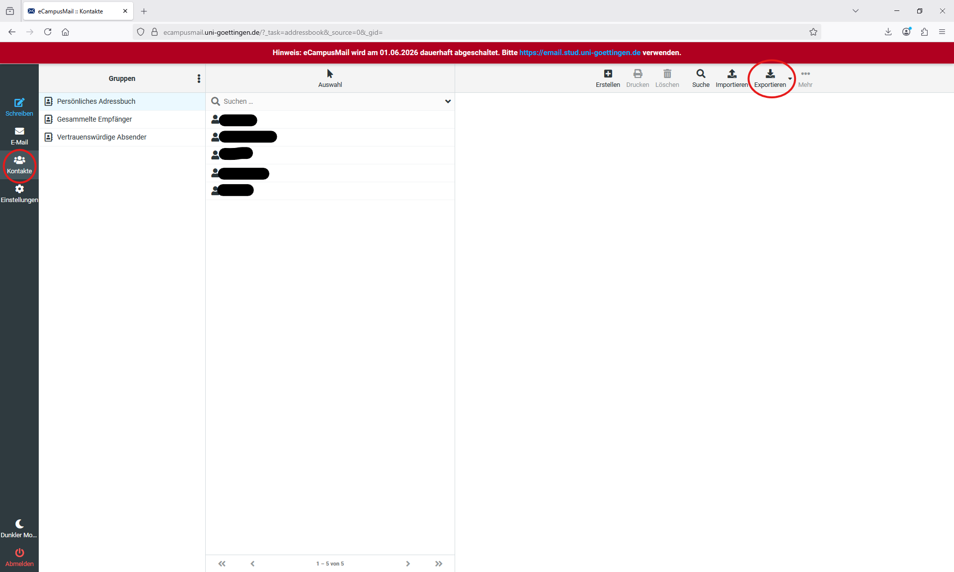
The vcf file is usually saved in the Downloads folder. Depending on your settings, the file may be named “Kontakte.vcf” or “contacts.vcf.”
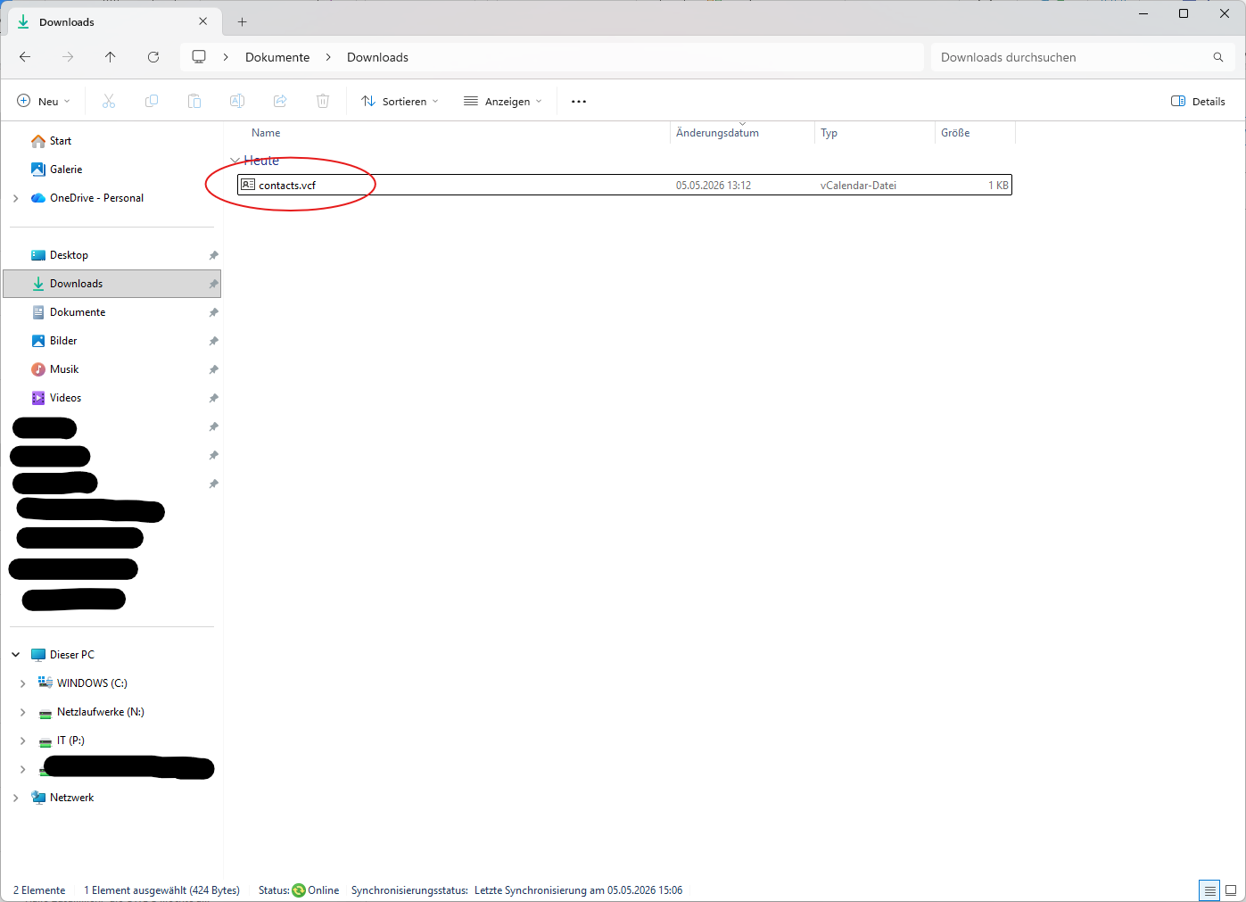
From here, you'll need to transfer the vcf file to your smartphone. You can send it to yourself via email or a messaging app, for example.

Android
Wenn die vcf-Datei dann auf deinem Android-Handy z.B. in der 'Eigene-Dateien'-App ist, dann musst du die Datei nur Doppelklicken und im nächsten Schritt auf 'Importieren' klicken.
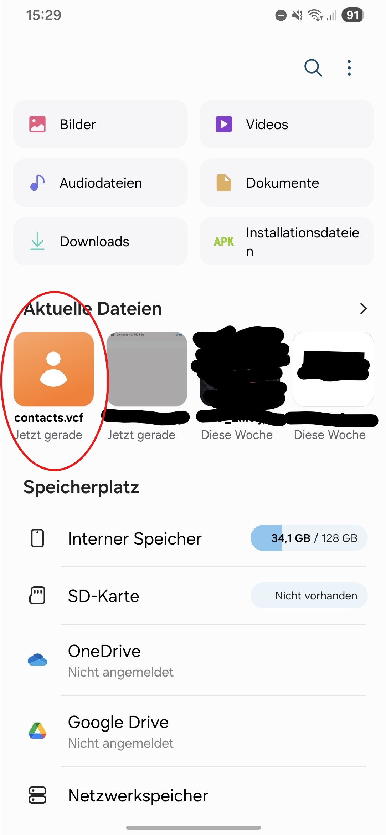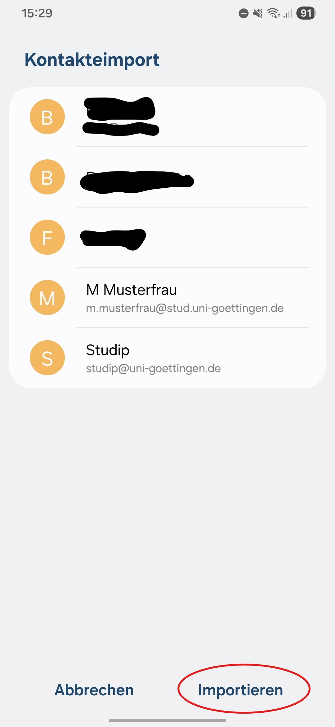
You'll then find the contacts in your address book.

iPhone
If the vcf file is located, for example, in the “Downloads” folder of the ‘Files’ app, you'll need to press and hold the file until an overlay appears. In this overlay, tap “Share.” The “Share Sheet” will then appear. In the “Share Sheet,” you may need to scroll to the side until you see the 'Contacts’ app.
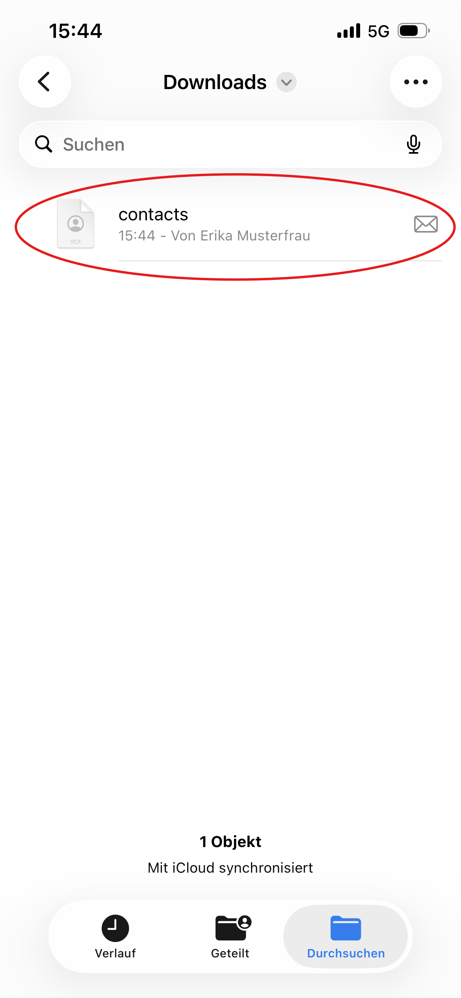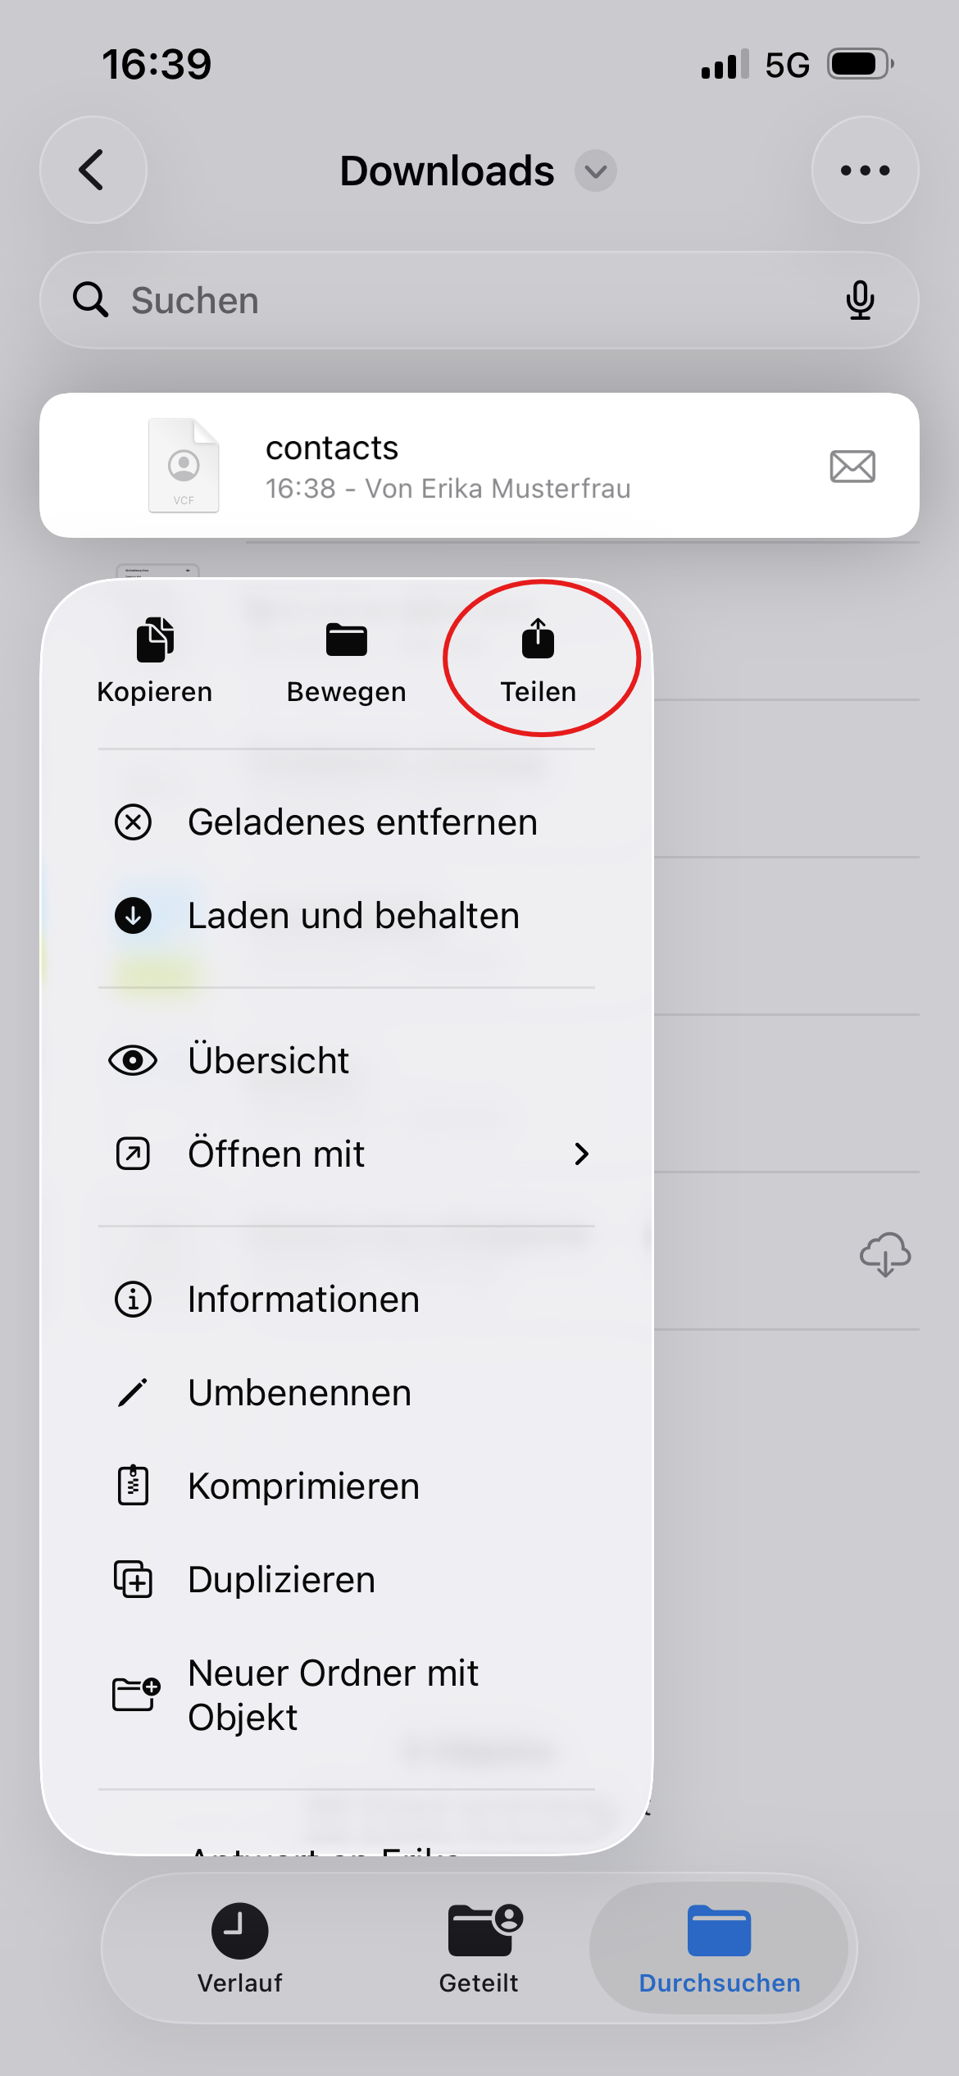
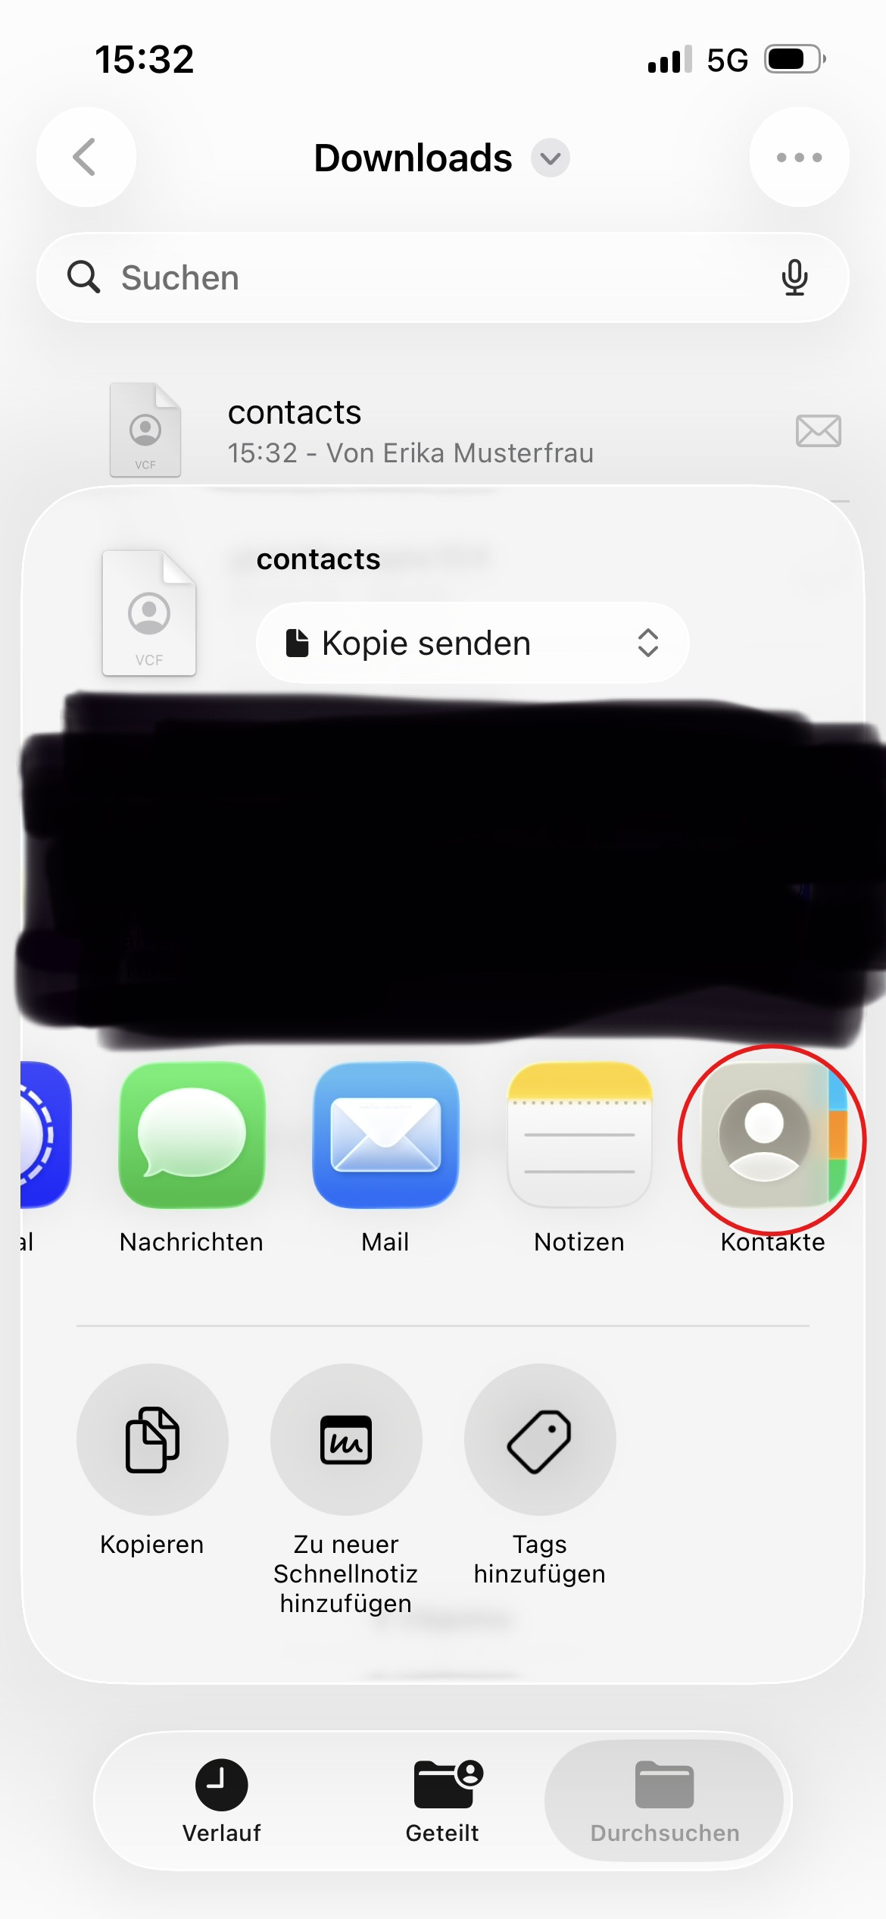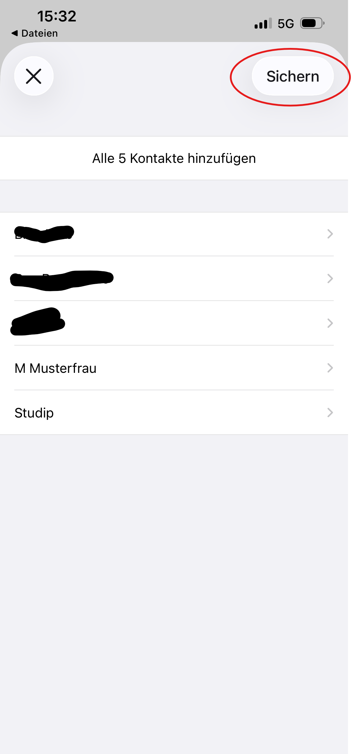
You'll then find the contacts in your address book.

