LRC SUB
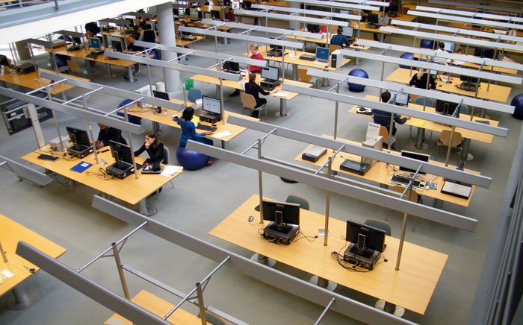
The LRC is a co-operative effort of Göttingen State and University Library, GWDG and studIT. You can find further information concerning the LRC SUB on our support pages or at the homepage of the SUB.

The consulting hours are:
- Monday, Wednesday, Friday 10 am to 4 pm
- Tuesday and Thursday 10 pm to 6:30 pm
- Saturday and Sunday 1 pm to 4 pm
At the LRC SUB you can use the following services:
- issuing of guest accounts
- resetting and regeneration of passwords for the student account (and also for the self-service functions)
- regular advice and assistance concerning the student account (including support concerning the Wi-Fi networks)
- advice concerning printer queues and printers
- expert consulting regarding the use of programs for academic purposes
The LRC SUB is located on the second floor of the Göttingen State and University Library (SUB).
LRC SUB Terms of Use
- No phone calls in the LRC, please.
- When working at the PCs please be quiet and keep talking to a minimum.
- No food or drinks, please. (excluding water in clear bottles)
- Please don't occupy workspaces unnecessarily. After 30 minutes of being idle, the computers will log you out automatically.
- Please be keep your workspaces clean and tidy.
- Please pick up print-outs within 72 hours. After that, any printed papers will be thrown away.
- When using your private notebooks, please use the designated notebook workspaces.
- Should you encounter a problem with a printer, please approach a StudIT employee. Do not touch displays and paper trays, please!
tag> studIT support LRC SUB

