Chip card issue point in the main lecture hall building (ZHG)
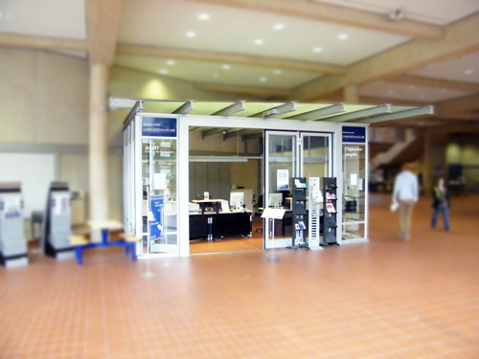
Location:

Opening hours:
Monday to Friday from 10 am to 5 pm.
There, studIT provides the following services:
- first-time issuing of your student ID
- issuing of student accounts
- resetting and regeneration of passwords for the student account (and for the self-service functions)
- regular advice and assistance concerning the student account (including support concerning the Wi-Fi networks)
- topping up the print contingent of StudITprinting accounts
- selling selected RRZN scripts
- renewing the semester rail ticket and the student ID (only during consulting hours)
You can find us between lecture halls 010 and 011 in the main lecture hall building.
tag> studIT support chip card issue point

